1. Download Sirenia
   1. Local source: J:\Med_Pulmonary\Admin\Sleep_Research\_VARGAlab\Software\**Sirenia_1_7_6.zip**
   2. Internet: <http://www.pinnaclet.com/sirenia-download.html>
2. Unzip and install.
3. Once installation complete, find application: C:\Program Files (x86)\Pinnacle Technology Inc\Sirenia\**Seizure.exe**
4. If having problems with installation, refer to this guide: <http://www.pinnaclet.com/PDF/sirenia_installation_details.pdf>
5. Double-clink on Seizure.exe (we’ll be using Seizure until we get the Sleep license).
6. Make a shortcut to desktop.
7. Locate the test recording in our J drive: J:\Med_Pulmonary\Admin\Sleep_Research\_VARGAlab\msRecordings\**test_2016-08-29_1hr.pvfs**
8. Save a version to your local hard drive for your own annotations.
9. Doc the video into the viewer (click-hold on video and drag to right panel):

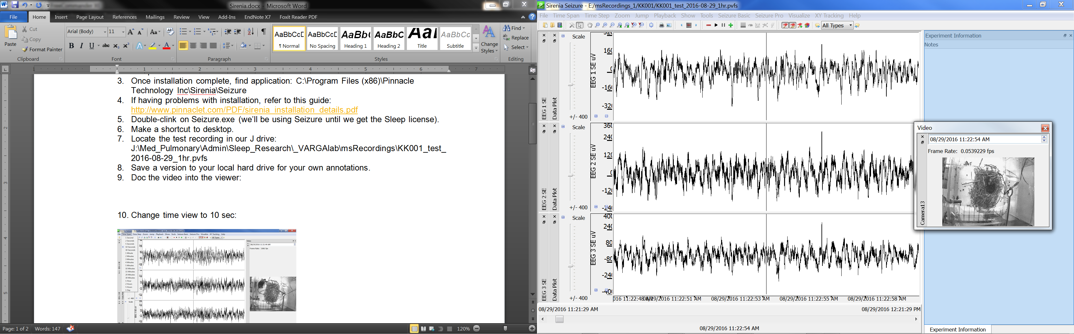

1. Change time view to 10 sec:

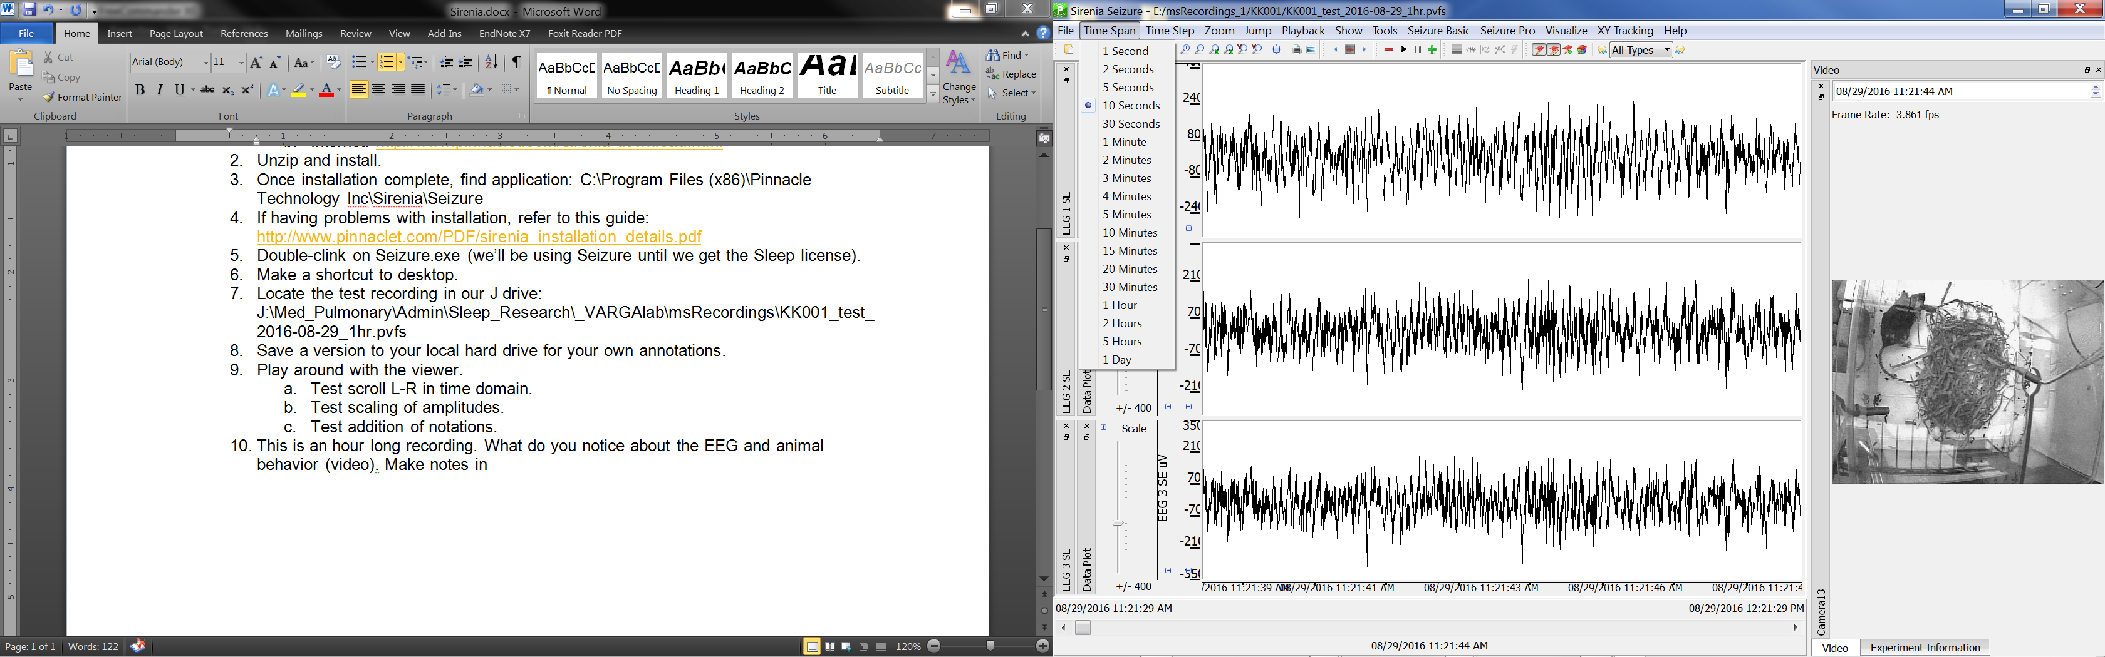

1. Change time step to 10 sec:

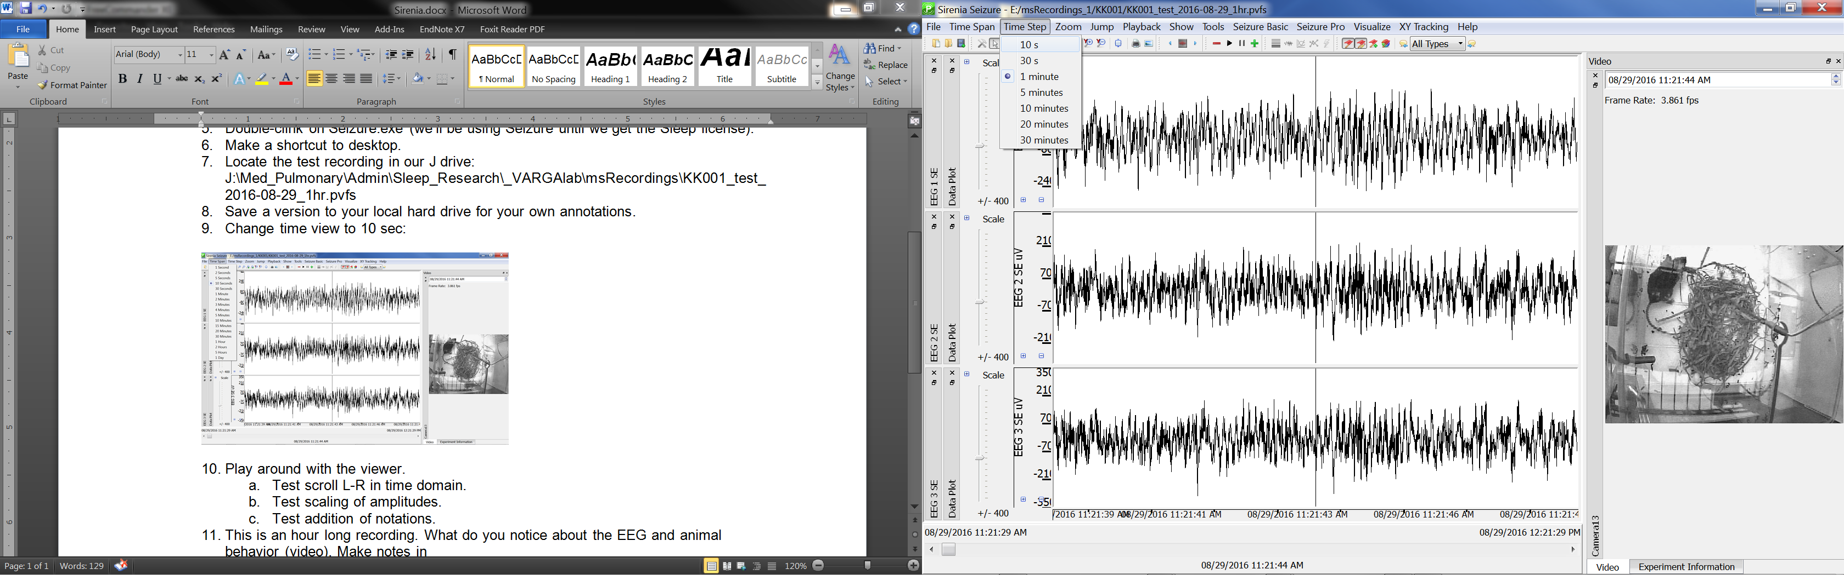

1. Play around with the recording and viewer functions:
   1. Test scroll L-R in time domain.
   2. Test scaling of amplitudes.
   3. Test addition of annotations.
   4. Jump between annotations
2. This is an hour long recording. What do you notice about the EEG and animal behavior (video tab). Record observations in the “Notes” tab.
3. Try Extracting a clip of interest. This is a good way to share a small clip of something interesting. Keep it small initially (10 sec) because the file size grows with recording duration:

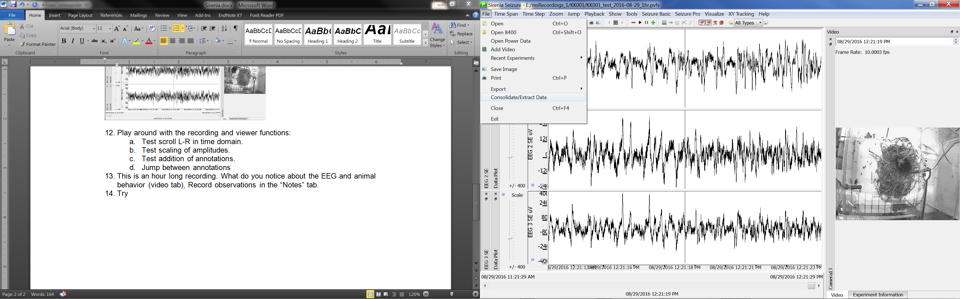

1. Apply notch filter (59-61Hz) and then see what changes…

